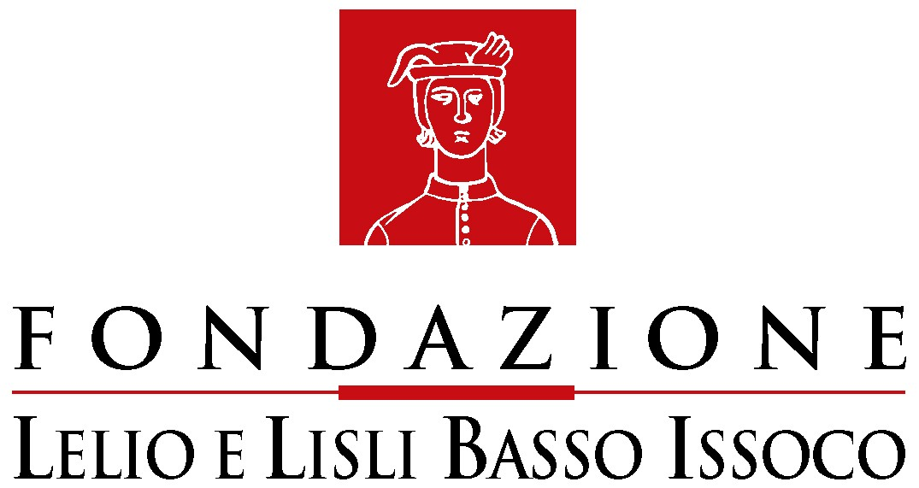   C.I.R.D.C.E.

Observatory on the respect of fundamental rights in Europe

Newsletter n.2

The reasons and the purposes of the Observatory on the respect of fundamental rights in Europe and its promoters have widely been illustrated in the first newsletter issued in March, a few days before the celebrations of the fiftieth anniversary of the signing of the Treaties of Rome.
The Observatory website – www.europeanrights.eu – it is now in operation and it offers the update on laws and European acts which are relevant on the issue of protection of fundamental rights.
Among the documents that have been recently inserted, we highlight the Resolution of the European Parliament of 15 March 2007 on “the respect of fundamental rights in the Commission’s legislative proposals: methodology for a systematic and strict verification”, the Resolution of 15 February 2007 on “waste materials”, the green paper of the European Commission about “consumers’ rights”, which has opened a public forum of discussion ending in May.
The website also offers the possibility of consulting two documents drafted within the forum, set up by the green paper, about the “modernization of labour law”, ended in March 2007, the first one by a group of professors, magistrates, and lawyers expert in labour law and the second one by Medel magistrates.
We believe that such a broadened and preventive exchange of ideas about the regulating action of the European Union, through debates introduced by documents open to a number of solutions like the green papers, is one of the most significant ways to build and strengthen a European public sphere, competent and able to assert its opinions.
With regard to the Council of Europe the four Resolutions of the Committee of Ministers of 4 April 2007 concerning, respectively, Italy, Poland, Turkey and relations among Cyprus and Turkey, must be pointed out.
The website has also updated the inserting of the main European Communities’ Court of Justice’s decisions: among the most important we refer to the decision of 13 March 2007, Unibet, with which the European Communities’ Court of Justice again refers to the Charter of Nice, together with the common constitutional traditions, and the decision of 27 February 2007, Segi, which extends the prejudicial jurisdiction of the Court to the common positions, taken with regard to so-called Third pillar policies, which are able to cause juridical effects to the persons they are addressed to.
The same updating of the case-law material has been done for the Court of Strasbourg; among the main decisions we highlight the new decision on the Scordino case, with which the European Court of Human Rights establishes very strict criteria about compensation for damages coming from dispossession and the decision of 19 April 2007, Vilho Eskelinen and others, which has referred to the Charter of Nice and the “explanations” attached to the Constitutional Treaty.
The website also offers some non-European decisions: the controversial decision of the Hague International Court about the Srebrenica massacre, a judicial measure of the Interamerican Court of Human Rights concerning Chile and a report on the first act of committal for trial of the International Penal Court.
With regard to the national case-law material, it is worth highlighting: concerning Spain, a complex decision of the Tribunal Supremo which, on the basis of the European norms about terrorism, evaluates the judicial measures adopted concerning some Basque associations (a dissenting opinion in particular enhances the Charter of Nice) and a decision of the Audiencia Provincial de Sevilla which also refers to the Charter of Nice; concerning France, a decision of the Council of State (which has been largely emphasized on the European media), which reasserts the Supreme Administrative French organ’s trend about the need of verifying the compatibility between the supreme values of the French Constitution and the principles of European law; concerning Great Britain, the decision of the House of Lords about the European Arrest Warrant.
With regard to Italy, the website has updated the surveying of the decisions referring to fundamental rights, which put into effect principles and/or rules of supranational origin of the Constitutional Court (among these we highlight the decision 117/2007 according to which the recent case-law of the European Court of Human Rights about trial by default does not imply further alterations to the Italian criminal procedure code) and of the Court of Cassation. Among the merit’s judges’ decisions we want to bring the attention on two decisions: a decision of the Court of Appeal of Florence on paid holidays, which has applied the Charter of Nice; a decree of the Court of first instance of Milan about the so-called right “to the interruption of life”.
In the website have been inserted, among the comments, the studies of the Cour de Cassation on the penetration of European law (in particular the European Court of Human Rights) in the French legal system. Among the comments have also been inserted: the column of Oreste Pollicino about the jurisprudence of the Eastern European Courts (about the different attitude of the court of Warsaw and of Brno about the European Arrest Warrant), the above mentioned contributions on the green paper about the modernization of the labour law, and the following short essays:
Gianfranco Amendola, The concept of “waste material”: The European Union is at logger-heads with Italy
Valentina Bazzocchi, The Segi case: towards an extensive interpretation of the European Communities’ Court of Justice’s jurisdiction within the third pillar
Giuseppe Bronzini and Valeria Piccone, The European Parliament and the European Communities’ Court of Justice revive the Charter of Nice
Roberto Conti, The conformative interpretation and the dialogues between national and supranational judges
Fabio Licata, The French Council of State between the national Constitution and the European law
Vito Monetti, The first committal for trial of the International Criminal Court
Giovanna Pistorio, The influence of the Charter of Nice in the European Communities’ Court of Justice’s decisions about personal equality and dignity

Notice: Bertinoro Summer School “The protection of Fundamental Rights in Europe”, July 8th- 13th 2007. The program is available on the website of CIRDCE.

