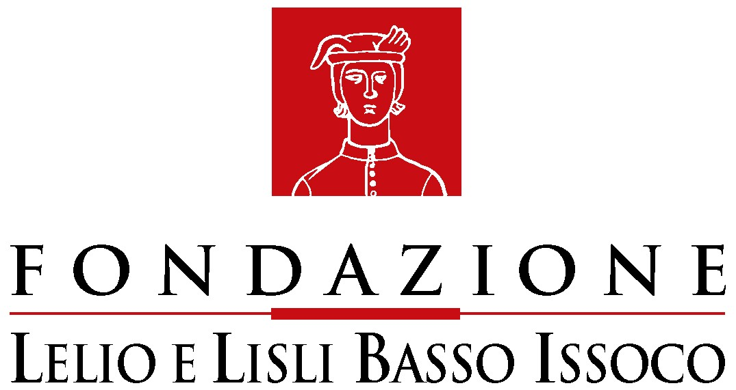   C.I.R.D.C.E

Observatory on the Respect of Fundamental Rights in Europe

Newsletter n.3

This is the third appointment with the newsletter of the Observatory on the Respect of Fundamental Rights in Europe.
The website Europeanrights has been updated with the main acts and documents adopted by the Council of Europe and by the European Union, as well as with the jurisprudence of the two supranational Courts in matters of fundamental rights (we recall that by fundamental rights we here mean all rights mentioned in the Charter of Fundamental Rights of the European Union). We have also carried on in the effort to document national case law applying norms or principles of European origin concerning those fundamental rights.
Among the international documents we have added the first arrest warrant issued by the International Criminal Court concerning the ongoing trial about the facts of Darfur.
Among the documents of the Union we mention: the Resolutions of the European Parliament on capital punishment, on homophobia, on the rights of workers on information and consultation, and on the right to a dignified employment for all; the Report of the European Parliament on the state of fundamental rights in the world, the Green paper on the right to access European Union documents and the annual report of the European Mediator, which mentions the Charter of Nice.
We have also added the Resolution of the European Parliament concerning the relaunching of the constitutional process and the conclusions of the European Council held in Berlin on June 21st and 22nd.
Among the acts of the European Union we have also added the Collective agreement on sexual harassment and on psychological violence on the workplace (met in the framework of the “European social dialogue”).
A very important agreement has been reached among European Union and Council of Europe for a coordinated protection of human rights, in whose preamble the Charter of Nice is mentioned: this has also been added to the acts of the European Union.
Concerning the jurisprudence of the Court of Justice we mention: decision May 3rd, 2007, on the European Arrest Warrant, in which the Court newly refers to the Charter of Nice; the decision which sanctions Italy on the matter of waste materials; and the conclusions of Advocate General Mengozzi in the Laval case, concerning the right to strike (a judgement which has raised some concern in workers’ unions), which also recall the Charter of fundamental rights.
Among the documents of the Council of Europe we would like to point out Resolution n. 1551 of the Parliamentary Assembly (and correlative Recommendation) on legality and State secret, as well as the Report of the President of the Legal Affairs and Human Rights Committee (Senator Dick Marty) on secret detentions and illegal abduction of prisoners.
Concerning the Strasbourg Court we recall the decision Copland vs. United Kingdom in matters of privacy and decision Tysiac vs. Poland on therapeutic abortion.
Passing on to national case law, we recall: decision by the House of Lords and by the Conseil d’Etat concerning violation of the ECHR and restoration of consequent damages; decision by the House of Lords on judicial duty to verify negligence on part of police forces in protecting the right to life; the decision by the House of Lords on the obligation to interpret national law in accordance with Community Law principles in determining whether parity of wages among men and women has been respected; the decision of the Cour de Cassation on the right to marriage of homosexuals; a decision by the Cour d’Appel de Pau on the European Arrest Warrant; the dismissal decree of the Prosecutor by the German Supreme Federal Court on the report filed against Donald Rumsfeld for crimes committed in Iraq.
As far as Italian jurisprudence is concerned, among the decisions of the Corte di cassazione we recall those on the European Arrest Warrant, on “ne bis in idem” and on indemnity for the resolution of agency contract (which applies the principles stated by the Court of Justice). We also point out two decision by the Tribunals of Milano and Genova concerning time-limited contracts and a decision by the Tribunal of Pistoia on the disapplication of national laws contrasting with the ECHR.
Among the Comments we have added>
Two documents by MEDEL, one concerning the inclusion of the Charter of fundamental rights in the Treaty and the other on the Green paper on consumers’ rights;
The document by the Italian Ministry of Labour on the Green paper on modernising Labour law;
as well as the following essays:
Valentina Bazzocchi, The decision of the Court of Justice on the European Arrest Warrant;
Giacinto Bisogni, A civil right for Europe;
Miguel Carmona, Review of the Spanish jurisprudence concerning the taking of DNA samples;
Roberto Conti, Jurisdiction, European law and search for new strategies for judge’s training;
Simone Gaboriau, A recent speech by Guy Canivet;
Ferdinando Lajolo, The liability of the State: now a word is enough;
Oreste Pollicino, The Tribunal of Warsaw deals with the “useful effect” of Community law;
Barbara Randazzo, The Markovic case;
Giovanni Salvi, Council of Europe and State secret.

